|  |
| --- |
| **Exam Microphotonics**  Prof. R. Baets & Prof. D. Van Thourhout  6/1/2020 Morning  Start a new sheet of paper for each question!! Write your name on all pages.  In parallel with the written open-book exam there will be an oral closed book discussion with both lecturers (about other questions). |

**Question 1**

Consider a plane wave with a wavelength of 1 μm incident under 45 degrees onto a reflective blazed grating.

The blazed grating is designed in such a way that the diffracted light field propagates back in the direction of the incident wave (such a grating is called a Littrow grating).

Calculate the grating pitch, the grating depth and the blazing angle for the two following situations:

1. The grating operates in first order diffraction.
2. The grating operates in second order diffraction.

**Question 2**

Consider the waveguide crossing (two waveguides crossing each other orthogonally) as shown in drawing (a) below. All waveguides are identical.

1. Write down a general expression for the S-matrix of this four-port. Assume that reflections can be neglected.
2. Now, in figure (b), port 2 and 3 are interconnected with each other. A two-port results. Derive an expression for the S-matrix of this two-port, starting from the four-port S-matrix of the crossing.

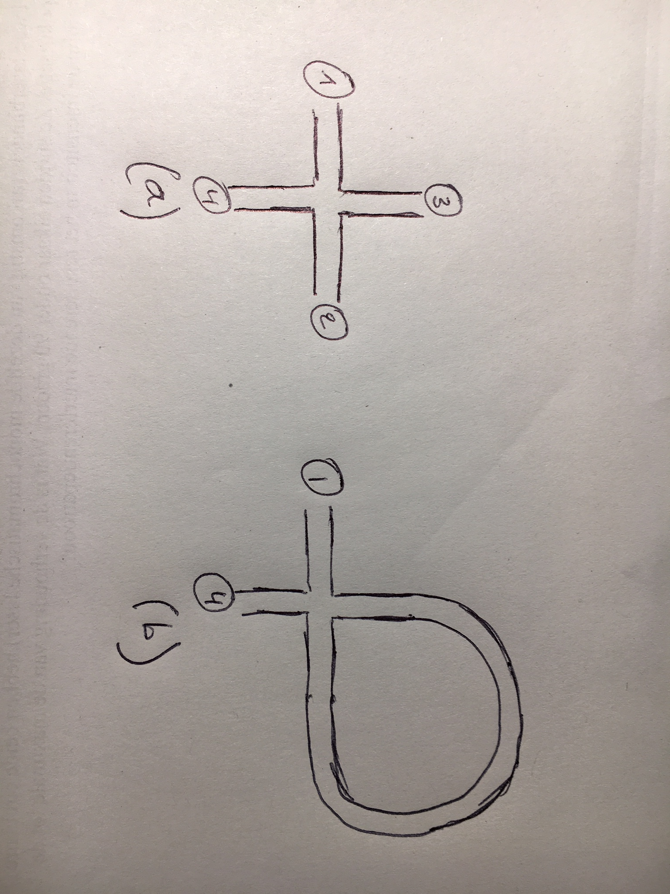

**Question 3 and 4: see back side of this page**

**Question 3**

Develop relation (5.108) by defining the maximum taper angle  using the relations developed in section 5.4.5 “Multi-mode interference coupler” (chapter waveguides).

a) Find a relation giving the maximum taper angle  as function of the wavelength, the refractive index and the width of the waveguide.

b) Make a qualitative plot of the taper angle as function of the width W of the waveguide, using this relation.

c) Now replace the width of the waveguide by the effective width Weff=W+2/. Make a qualitative plot of the taper angle as function of the width W of the waveguide. (The effective width was defined in the exercises,  is the distance over which the field decreases by a factor 1/e in the cladding layer).

**Question 4**

a) Why do we in practice often use multiple order phase plates instead of a single order phase plate?

b) Give an expression for the wavelength dependence of such a multiple order phase plate.

c) Based on b) : explain the drawback of multiple order phase plates in quartz and propose a solution to overcome this drawback.